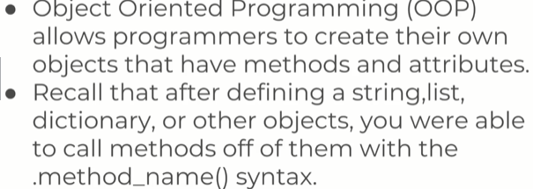

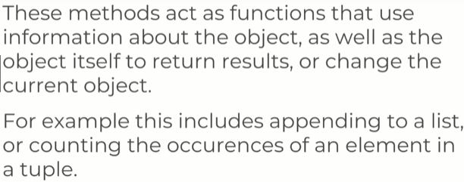

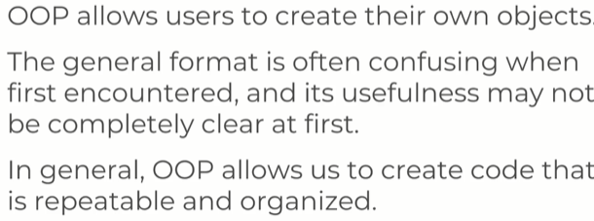

You need to learn OOP to make sure your program itself are flexible.
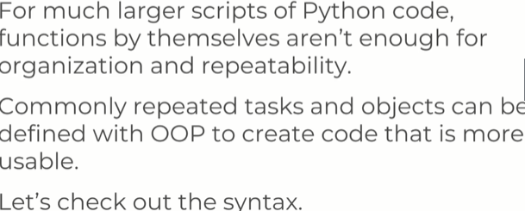

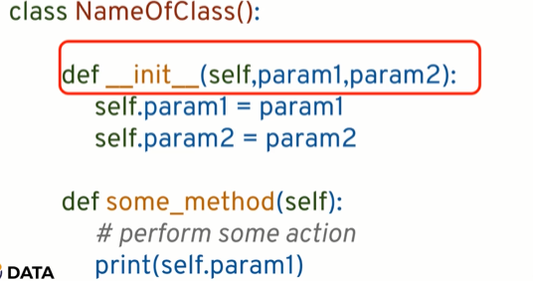

The red box is a thing that looks a lot like a function, but its called a method when inside a class.
We have _ _ init_ _ method , this allows us to create an instance of the actual object.
We have _ _ init _ _ ( self, param1, param2) , here param1 and param2 are the parameters that python wants u to pass. When u create an instance of this object.
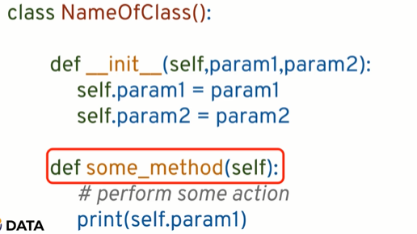

You pass the self keyword to let python know that this isnt some function, its a method that is connected to this class.

Object Oriented Programming – Attributes and Class Keyword
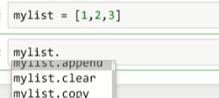
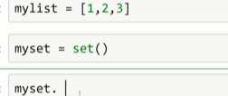
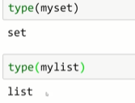

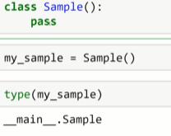

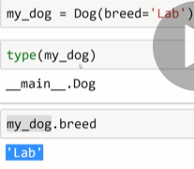

init can be thought of as a constructor for a class and its gonna call automatically when u call an instance of a class. The self keyword represent the instance of the object itself and most OOP languages pass this as an hidden parameter on the method defined on the object.
In python, it doesnt do this, you have to do this explicitly.

Note: Later when u r a programmer and python being so flexible
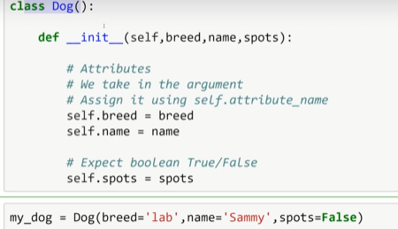

and you are expecting other people to use your Classes, you need to provide documentation to let them know that u r expecting
String for name, String for breed, Boolean for spots.
Cuz you can do this

and there is no type check.

OOP PART 2: CLASS object Attributes and Methods.

There are maybe attributes that are going to be the same for any instance of the dog class, we know it doesnt matter a dog has certain breed or certain name or spots.
Its always gonna be a mammal.
Something you wanna do, is define an attribute on class object level.
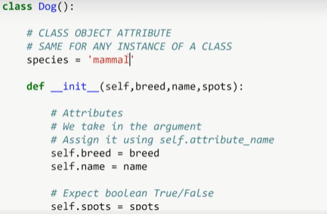

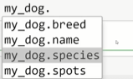

method is a function inside of a class, that will work on the object some way.
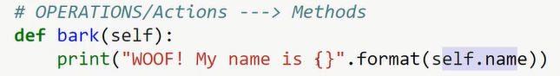
OOP Part 3 – inheritance and Polymorphism

inheritance is a way of forming new classes from the classes that were already defined.
The really important benefits of inheritance is the ability to reuse code that you already worked on and reduce complexity of a program.
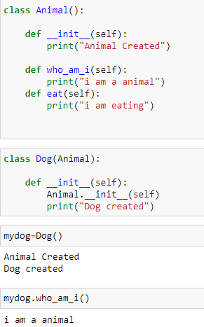

Polymorphism:
refers to the way that different object classes can share the same method name
and those methods can be called from the same place even though variety of different objects might be passed in.
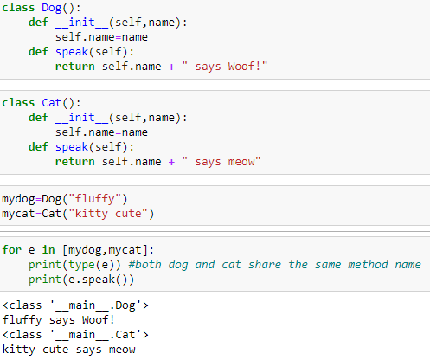

another e.g
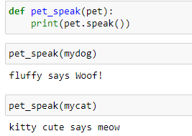

On both cases we are able to pass in different objects and we obtain object specific result from the same mechanism, same method call.
More common practice is to use abstract classes and inheritance.

An Abstract class is one which is never expect to be instantiated. Instead its only design to serve as a base class.

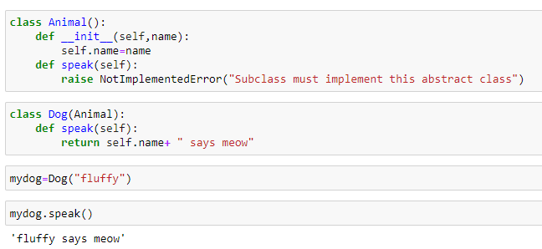
Real life e.g of polymorphism
- is opening different file types
So a method open() , but there is a lot of different files(pdf,excel).
You are trying to make a class thats a base class for opening files and u have other classes that inherit that. So for e.g a class for opening cdv, word , excel.

You want them to share the same method name <some class object>.open()

Object Oriented Programming P4 Special (Magic/dunder) Methods

Special methods allow us to use some built-in operation in python such as the length function or the print function with our own user created objects.
An e.g
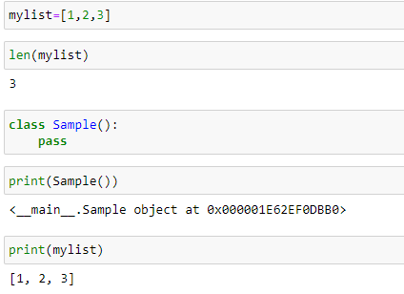

So the question is how am I able to use buit in python functions such as length or print with my own user defined object ?
Solution is Special methods or Magic or Dunder methods.
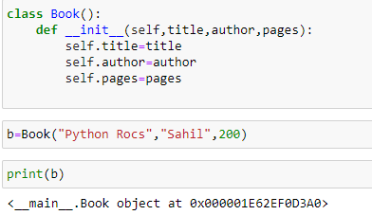

it just give the object location in memory
So what happens is, when u use print function, the print function ask what is the string representation of b

so if I try to transform b into a string, I got a string version of object memory location.
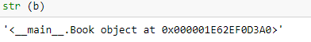

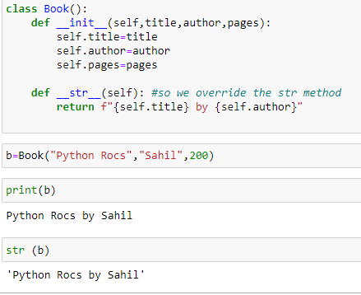

we got the same output from print and str; cuz the print function does is it prints out what is the String representation returns back.
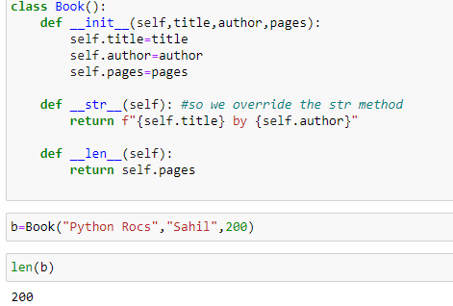

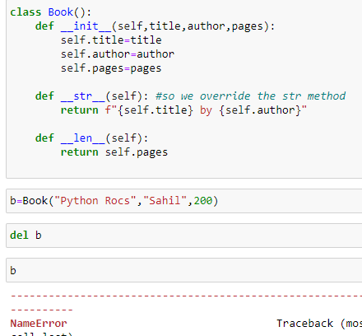

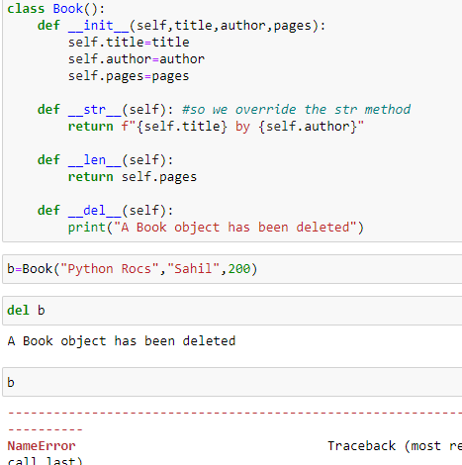

Decorators with Python overview
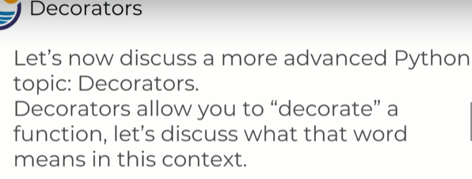
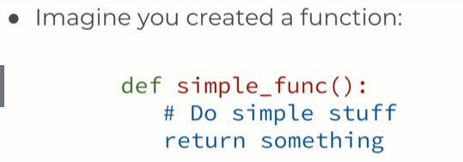

So u created this simple function and now you wanna add more functionality to it or IOW add more code.
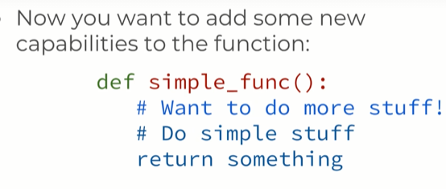

what you code do is take ur original simple func and adds some more stuff to it and keep doing the old stuff n return something

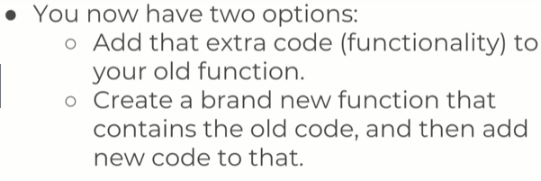

1. You have two options here, adding functionality to your old function bu then you have a problem about not being able to call your original function.
You edited in someway with that new functionality.
2. Other way is to create a brand new func where you copy your old code and added your new code to that. The problem is now u have to recreate the entire function all over again.
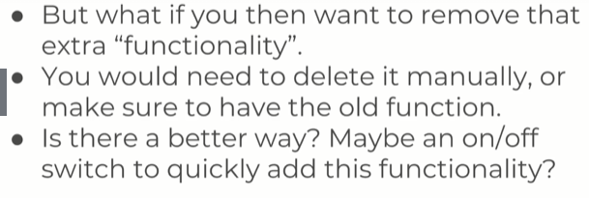
This is where a decorators come at play.
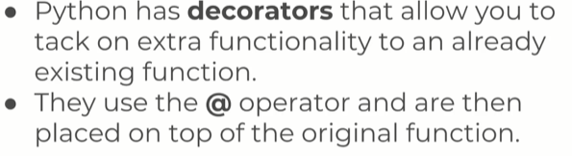
Now if u no longer want that function , u just delete the one line from the decorator.
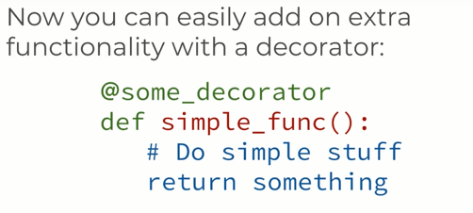

so
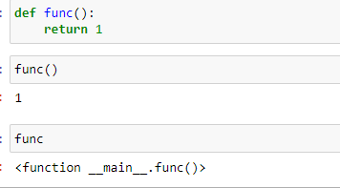

when u print a function, u’ll get info about “you have a function here”, you wont actually execute it.
That means we can assign func to other variables and execute them off the variable.
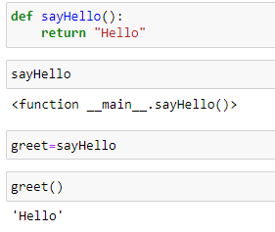
So what we gonna ask is greet pointing to sayHello? Or made his own copy of sayHello?

That is
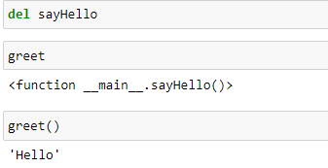
So even though we deleted sayHello, the name greet is actually still pointing to that original function object. Its important to note func and object can be passed into objects.

Having a func within a function.
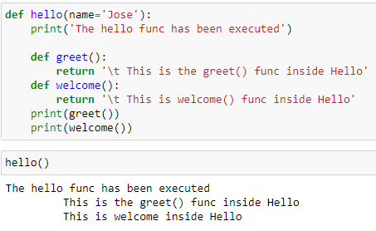

One thing to notice, is greet() and welcome() is only defined inside the hello func, not outside. That means there scope is limited to hello() func .
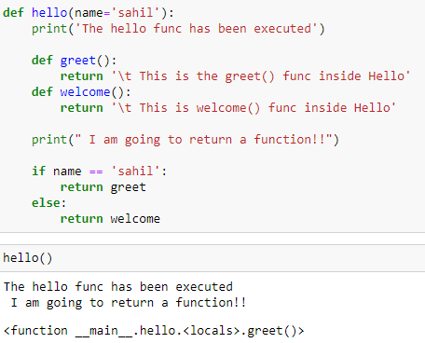

we can assign the func that is returned to a variable.
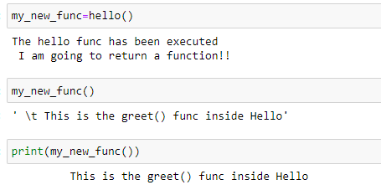

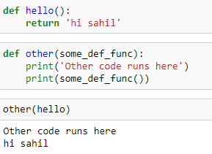

So decorators starts now
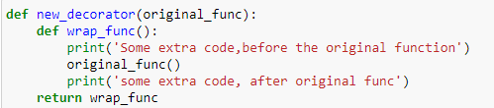

You can think about this as a present with some wrapping paper, the original func is the present we gonna put essentially inside a box and wrap around it, this why its called decoration.
Wrapping paper is some extra code that goes on top of the func or after it below the func.

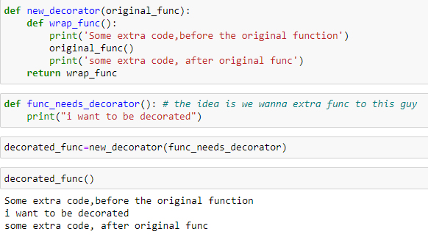
Easier way Using decorator is:
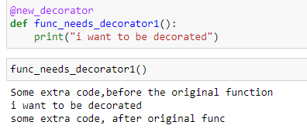

Using decorator u didnt need to pass the func to be decorated inside a decorator and then assign it to a variable.
Now u just can “ @new_decorator” you can easily decorate and remove decorate by
removing this line.

Generators
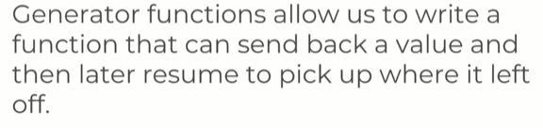

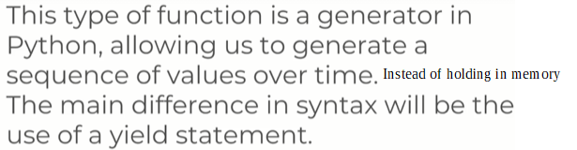
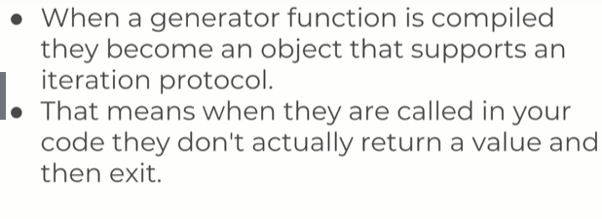
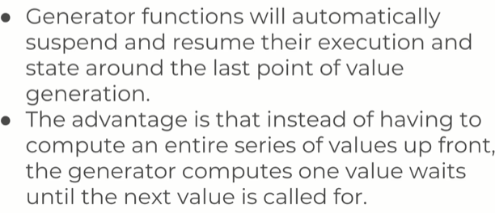

So you can imagine you want all the number between 1 and 1 million.
You have 2 options here, you can either start generating values 1,2,3,4 feed them that way in a for loop.
Or
Create a giant list of no from 1 to million and slowly pickup the numbers from the memory.
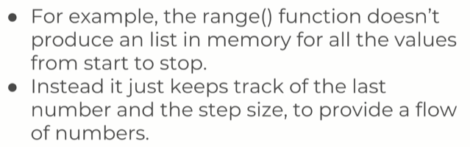
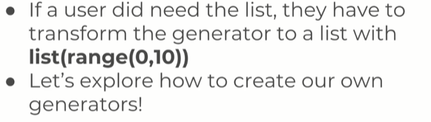
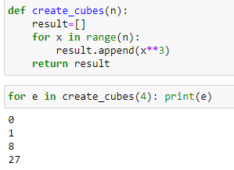

what happens when we print them, is actually we only needed one value at a time to print them we dont need the whole list store in memory. In fact, we only need the previous value and whatever the formula is to get the next value in order to generate all these cubes.

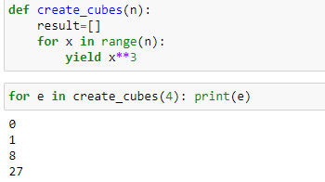

now create cubes is way more memory efficient, b4 we have to store the entire list of no in memory. But now , we dont have that list in memory so we are yeilding the value as they come, so create cubes here is a generator.
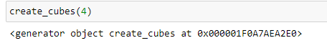

keep in mind, if u call createCube itself, you dont see the list. You only see there is a generator object in memory and u have iterate through if u want the actual numbers.

